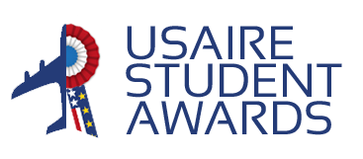
USAIRE STUDENT AWARDS 2024
Propose a specific and concrete project
with an associated business case that you hope
will disrupt the aerospace industry by 2040
One Pager
Submission date
Candidate 1
First Name :
Last Name :
School :
Nationality :
Email :
Phone number :

If in pair,
Candidate 2
First Name :
Last Name :
School :
Nationality :
Email :
Phone number :

How did you hear about this contest?
This one-pager should be sent before April 21th 2024 to the following addresses:
student-award@usaire.org and oraje.info@gmail.com. It may be written in French or in English and should not exceed the page hereafter, with a limit of 500 words.

