Usaire student awards 2021
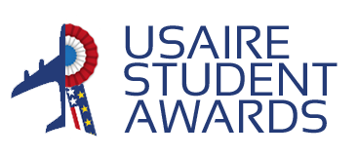
“What Aviation for tomorrow's World?”
One Pager
Submission date
Candidate 1
First Name :
Last Name :
School :
Nationality :
Email :
Phone number :

If in pair,
Candidate 2
First Name :
Last Name :
School :
Nationality :
Email :
Phone number :

This one-pager should be sent before May 2nd, 2021 to the following address:
student-award@usaire.org. It may be written in French or in English and should not exceed the page hereafter, with a limit of 500 words.

